Controls metadata widget - Hippogriff - UX Brief
The purpose of this document is to describe the UX request at a high-level. The document will be used to aid in planning and prioritization of the request.

1. Project at-a-glance

Author of this document | James Y. Huntley
Date of last update | 7/19/2024
Project Name | Hippogriff - Controls catalog metadata widget
Intake ticket | ---
Domain Group | Control Tower
High-level description | Project Hipogriff is the code name for the creation of the Controls Catalog (CC) namespace, which unifies all managed controls into a single-source of truth. The long-term vision is to include a front-end widget for discovery of controls from CC.  The project scope involves new API's, a new ontology and a 'meta data' widget that will ensure the control details are consistent. The first consumers of the new ontology and widget will be Control Tower and Config.
Requested by | Arnaud Coulondre
Submitted on behalf of | Arnaud Coulondre
Target launch date | re:Invent 2024 (December 2, 2024)  Q1 2025
Scope | Medium
Slack channel(s) | #prj-hippogriff-ux  #hippogriff-v1-release
Reference documents
Asana Project | https://app.asana.com/0/1205972465567785/1205973027223978
PRFAQ | https://amazon.awsapps.com/workdocs-preview/index.html#/document/c170e61582be2eda33d103fb9cc5ca874d870e5c689e3f777a7dc769ed1c6d28
Metrics plan
Stakeholders
Product lead (PMT) | Ellie Ray
Program management (TPM) | ----
Service team SDM | Kyle O'Connor
Console SDM | Tauseef Jamadar
Eng lead | Mark Meredith
UX designer | James Y. Huntley
UX researcher | ---
Tech writer | Leslie Lundquist

2. Schedule and effort estimates
Effort estimations are high-level, and based on the project requirements known at the point in time of writing the UX brief. Completion dates are provided in business weeks and some effort may run concurrently within the same week.
 | A | B | C
1 | Effort and task summaries | Estimate (wks) | ECD
2 | Start date |  | 7/15/2024
3 | CX deep dive |  | 7/19/2024
4 | Kick-off meeting, create User stories doc, create Decisions doc, refine customer stories with PM | 1
5 | Generative research |  | 7/26/2024
6 | Look through past research, discuss customer feeback with PM | 1
7 | UX design |  | mm/dd/yyyy
8 | User flow diagrams and wireframing | 1
9 | Create directional designs | 2
10 | Align directional UX with stakeholders, partners and SME's | 2
11 | Validation |  | mm/dd/yyyy
12 | Create test plan and collaborate with UX research team and stakeholders
13 | Prepare prototype for testing
14 | Recruit participants
15 | Run tests or conduct interviews
16 | Review findings, synthesize data into a report, share with stakeholders
17 | Finalize UX designs |  | mm/dd/yyyy
18 | Align designs with project stakeholders (PMT, Engineers, marketing, etc.) | 2
19 | Review with IDCG UX team and UX leads | 1
20 | UX Milestones review and sign-off, accounting for time to make adjustments | 1
21 | UX hand-off (date needed by) |  | mm/dd/yyyy
22 | Create hand-off documentation, meet with console and walk through use cases and design specifications | 1
23 | Development |  | mm/dd/yyyy
24 | Create metrics plan | 0.5
25 | Bug bash and dev support
26 | UX Milestones Fit & Finish accounting for time to make adjustments | 1
27 | Total effort and Launch GA | 13.5 | 12/2/2024

3. Goal and UX scope summary

3.1 Goal
The goal of Project Hippogriff is to improve consistency when viewing AWS managed controls by consolidating controls from AWS Control Tower and AWS Config into a new namespace, Controls Catalog. Controls Catalog will be the single authoritative system of record with a new ontology common to every managed control. Customers who are looking to achieve governance objectives with either Control Tower or Config controls will onboard to AWS services with increased confidence knowing the meta data of those controls are consistent and controls map to the same frameworks consistently. Because of the single namespace, Config controls will be identical in meta data, mapping and UX when those controls are discovered in CT or within the Config management console.

The below screenshots exemplify the problem of inconsistent meta data displayed per control. The format, meta data, and mapping is unique per display in each console.
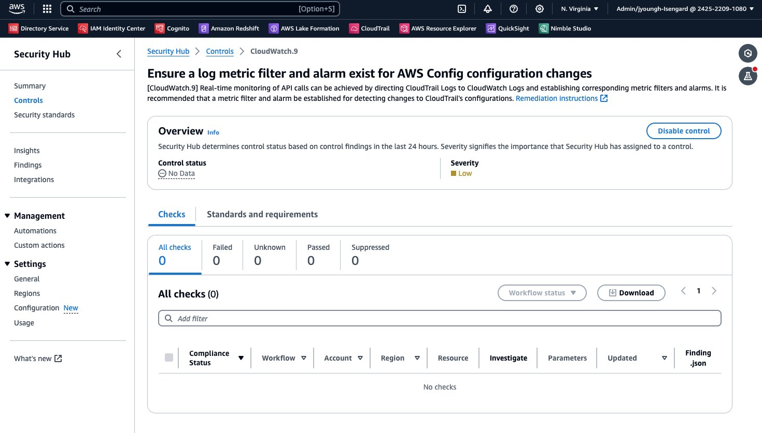
Screenshot 3.1.1 Example of format of control detail in Security Hub
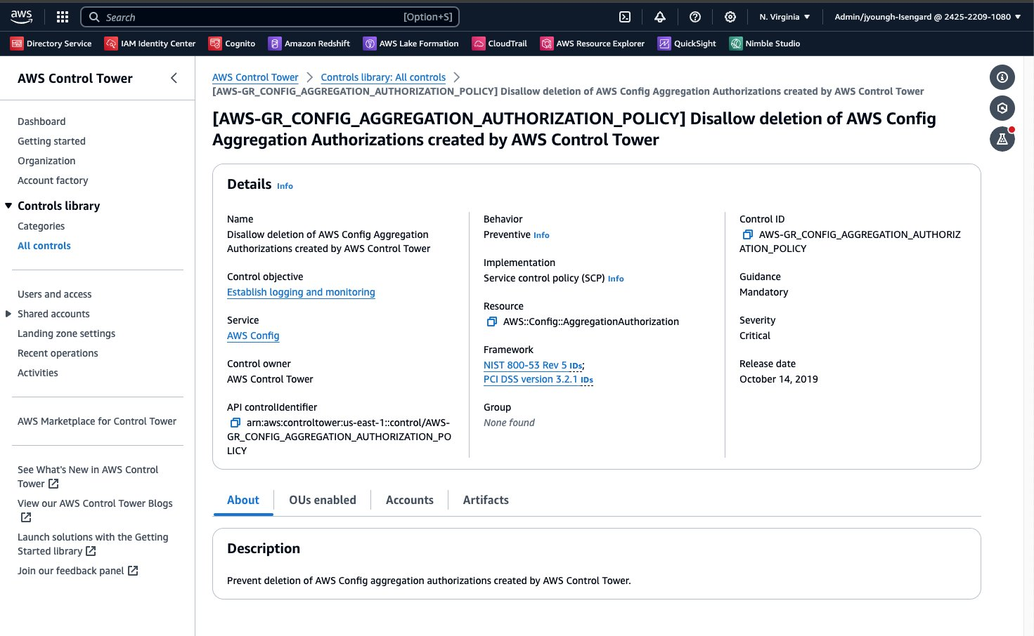
Screenshot 3.1.2 Example of format of control detail in Security Hub

3.2 UX scope summary
The controls will be classified under a common ontology and mapped consistently to additional compliance frameworks.
Control Tower and AWS Config will be the first service to consume Controls Catalog, and other AWS services will follow in 2024, including: AWS Security Hub and Audit Manager. The UX will allow a customer to easily find the controls they need in:
- A single pane of glass within Control Tower that provides discoverability of the existing 900+ Control Tower controls with 400+ AWS Config controls via a new single API. This will include minor UX updates to the index table (columns) of the CT UX to account for the updates to meta data.
- A new Controls Catalog meta data widget that will provide a common display of control meta data that can be implemented into AWS service management console teams for consuming of the new Controls Catalog AP'I's with common UX. This widget would be the new display of the control “detail page.”

3.3 Projects driving underpinning capabilities
- Control versioning: Providing the ability for controls to display versions when a managed control in Control Tower is updated to a newer version and provide the customer the option to update to the latest version. This includes relevant notifications within control indexes (GA end of September 2024)

4. User personas
Persona resources: AWS Identity Personas | AWS personas (New)
Image | Persona | Avatar name | Primary goal | Primary opportunity from project
 | Cloud platform architect  (aka Cloud Implementer) | Sam | To design and maintain a secure infrastructure through a combination of policies, compliance and governance controls. | Controls Catalog improves the efficiency I have to find and understand the AWS managed controls I need to enable to achieve the governance outcome I'm looking for.
 | Security Engineer | Tim | To safeguard access, manage the uber security of the organization and interpret information across policies, documentation, logs, and other tools linked to all company accounts to verify that we are compliant with company requirements. | Controls catalog provides me the confidence that the controls in Config are mapped to the same frameworks as Control Tower controls and that the meta data is consistent across our AWS environment.

5. UX narrative (problem and solution)

“I want to easily find all AWS managed controls in one place for consistent coverage to known frameworks.'”

5.1 Problem and opportunity
Sam is a cloud platform architect for MSKCC and received notice from the security team that Amazon Bedrock has been approved for allow-listing. “This is really cool!” Sam thinks to herself as she read about how generative AI capabilities have benefited other med tech institutions. Sam wants to be sure that the use of Bedrock meets all of their regulatory compliance. In order to do so, Sam is ready to begin the research into the necessary controls to establish governance coverage with the new Amazon Bedrock service ahead of its deployment. She had set up a landing zone with AWS Control Tower when they began onboarding to AWS services to manage their cloud governance, and is familiar with AWS managed controls.

“AI is so new, and I’ll have to allocate time to research the various controls necessary to ensure we are compliant and secure,” Sam thinks to herself. Sam experience in setting up the governance structure for AWS services before, and knows from past experience that Control Tower isn’t the only source of controls. In those past setups, Sam’s team has had to research and perform a gap analysis to best understand how the controls in Control Tower overlapped with those in Config and Security Hub. In the end, she had begrudgingly made the decision to use third party controls to get the governance outcome she was looking for.

Sam receives a notification of a new Control Tower feature namespace Controls Catalog. The notification informs her that the Control Tower controls and AWS Config’s 400+ managed controls have now been mapped to a single controls namespace. “That makes sense, and will alleviate my team from having to understand controls across AWS,” Sam thinks to herself.

5.2 Solution
Sam logs into her AWS management account and navigates to the Control Tower management console. From the side navigation, she navigates to Controls library > Categories. Sam clicks the Frameworks category tab where she sees that from the original 3 frameworks, there are now 22 frameworks with Control Tower and Config mapped controls. From the Services tab, Sam selects ‘Amazon Bedrock’. As she explores the table of available controls, she sees some of the columns have been updated (i.e. domain, control objective, common controls, standards controls, AWS control intent and AWS control implementation). “This will make it a lot easier to understand behavior controls mapped with consistent meta data.”

The following week, Sam is running through her jobs to be done and is in a meeting with Tim whose team manages their AWS Config environment. Tim tells Sam because of Amazon Bedrock, they will need to update controls for the HIPAA-Security-Rule-Feb-2003 framework. “Should I set up our usual team gap analysis review to understand how Control Tower and Config each map to this framework? I know this can be a lengthy process.” Tim says to Sam. Sam grins and replies: “Nope, we should be good! All AWS Config controls are now mapped to the frameworks in the same way Control Tower controls are mapped.” Tim looks unconvinced. Sam turns her laptop around and shows Tim that the same control he referenced for the same framework is shown identically in both Config’s console and the Controls Catalog in Control Tower. “Cool, even the control details are the same. This is going to make our jobs much easier!” Tim exclaims.

6. Research needs

6.1. UX research needs

Research needed | Yes | No | Notes
Customer interviews | ✅ |  | We need to know how do customers normally seach for controls – what types of outcomes are common; this will improve the SSF mechanism. It would be good to know what the concerns with inconsistencies are and where the painpoints are in adopting AWS managed controls.
Metrics / data reporting | ✅ |  | What controls are configured most common and what controls are updated most frequently
Usability testing | ✅ |  | Test the widget and the front-end UX within CT — how will this shape a customer's understanding of what Control Tower is

6.2. Description of needs
Controls are currently spread across multiple services. In centralizing all managed controls to a common ontology, it is important to understand what customer pain points are with the inconsistencies, where there is opportunity to improve upon the search, sort and filter UX and how to surface commonly used controls for the majority of our customers.

7. Related links

7.1 Documents
- (Ellie) Ontology document - Shared via Slack July 23, 2024
- (Ellie) Requirements - CT Adoption of Ontology Metadata: https://quip-amazon.com/buaQAa0BUVQP/CT-Adoption-of-Ontology-Metadata
- (Arnaud) (OLD) PR/FAQ: https://amazon.awsapps.com/workdocs-preview/index.html#/document/defd496a065000eeddc6e7a2103ca0996585766bad3c8c62e963649ef50438e5
- (Arnaud) (OLD) Hippogriff naming: https://amazon.awsapps.com/workdocs-preview/index.html#/document/50868fac57c9279ac6d4e3f1689c54b2a73f1ff66aa9ba2b27d22974dfa64df9

7.2 Related articles and products
- Security controls in the governance framework: https://docs.aws.amazon.com/prescriptive-guidance/latest/aws-security-controls/sec-controls-gov-model.html
- Smartsheet governance controls: https://help.smartsheet.com/learning-track/system-admin/governance-controls#:~:text=Governance%20controls%20allow%20System%20Admins,set%20and%20enforce%20policy%20restrictions.

